ONEWAY SA BY DAW
/STATISTICS DESCRIPTIVES HOMOGENEITY WELCH
/PLOT MEANS
/MISSING ANALYSIS.

Oneway

Notes
Output Created |  | 05-May-2019 23:26:39
Comments
Input | Active Dataset | DataSet0
Input | Filter | <none>
Input | Weight | <none>
Input | Split File | <none>
Input | N of Rows in Working Data File | 30
Missing Value Handling | Definition of Missing | User-defined missing values are treated as missing.
Missing Value Handling | Cases Used | Statistics for each analysis are based on cases with no missing data for any variable in the analysis.
Syntax |  | ONEWAY SA BY DAW  /STATISTICS DESCRIPTIVES HOMOGENEITY WELCH  /PLOT MEANS  /MISSING ANALYSIS.
Resources | Processor Time | 00 00:00:00.141
Resources | Elapsed Time | 00 00:00:00.157

[DataSet0]

Descriptives
 | N | Mean | Std. Deviation | Std. Error | 95% Confidence Interval for Mean
 |  |  |  |  | Lower Bound | Upper Bound
1-3 days a week | 12 | 35.9167 | 18.42162 | 5.31786 | 24.2121 | 47.6212
3-5 days a week | 5 | 14.4000 | 7.66812 | 3.42929 | 4.8788 | 23.9212
5-7 days a week | 13 | 22.6923 | 13.46220 | 3.73374 | 14.5572 | 30.8274
Total | 30 | 26.6000 | 16.74062 | 3.05640 | 20.3490 | 32.8510

Descriptives
 | Minimum | Maximum
1-3 days a week | 15.00 | 67.00
3-5 days a week | 6.00 | 24.00
5-7 days a week | 5.00 | 60.00
Total | 5.00 | 67.00

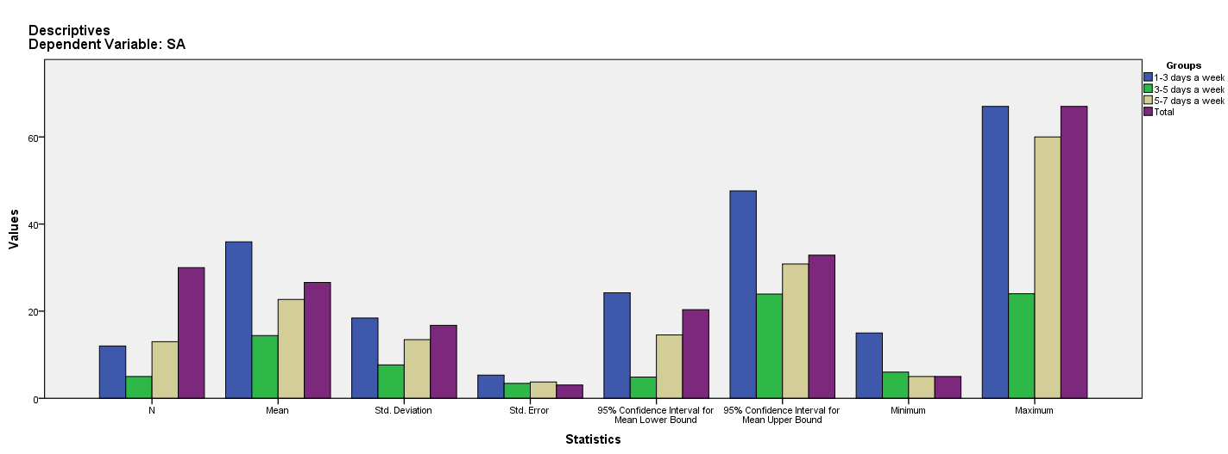

Test of Homogeneity of Variances
SA
Levene Statistic | df1 | df2 | Sig.
2.857 | 2 | 27 | .075

ANOVA
SA
 | Sum of Squares | df | Mean Square | F | Sig.
Between Groups | 1984.314 | 2 | 992.157 | 4.361 | .023
Within Groups | 6142.886 | 27 | 227.514
Total | 8127.200 | 29

Robust Tests of Equality of Means
SA
 | Statisticª | df1 | df2 | Sig.
Welch | 5.628 | 2 | 15.601 | .014
a. Asymptotically F distributed.

Means Plots

